## **Final Plan**

Project Name: Lighthouse

Prepared by: Kurt Newcomb

Date: 9/4/2022

|  |
| --- |
| Design Planning Summary |

Given the premise of the Capstone Project was to create a full application that does some good for the world, I got to thinking about how several people I personally, and care very much for, are all suffering from severe emotional trauma and the resulting stress. The stress and overwhelming emotions that they experience, often to a debilitating degree, prevent them from helping themselves solve their problems on their own, until the feelings subside naturally. The problem is the damage that they incur during that time, which led me to my idea for the project. I came up with the idea for Lighthouse because I always like to remind them to keep their eyes on the prize, as in… it’s okay to struggle here and there, so long as you keep trying to make a little progress each day, like a boat following a lighthouse in the dark night.

So, the application is going to be a tool that someone, who experiences or is experiencing emotional stress and trauma, can use to help guide themselves through the trauma or help themselves work through the stress that they are experiencing from overwhelming emotions. The application will have a feature designed to engage the user’s logic and critical thinking centers of the brain, which typically get shut down when someone is experiencing extremely heightened emotional states, therefore… in order to help counteract and decrease the heightened emotional state, we shall reengage the logic center by walking the user through a diagnostic process of the emotions. The user will have to answer questions like, what emotion are you currently experiencing, what was the last thing you remember before you felt this way, what do you want to do because of it, do you think feeling this way is healthy, etc. Making the user answer these questions will take them away from feeling the emotions to looking at them from the outside, which should help them not suffer as much under their weight.

After the user goes through the analysis process the application will create a memory of the event and put it into a timeline that the user can go back through to reflect on it, and even add comments from the future to reflect on what they have since learned and talking to their past self, might help them adjust more positively.

On top of the critical analysis and diagnostic nature of the application, there shall also be a feature that will promote positivity and positive thinking, at the moment through an affirmations feature, which shall contain a list of affirmations the user has that they wish to hold. As an additional feature for the applications, I’m toying with the idea to randomly pushing a notification to the user’s phone at some point during the day with one of the affirmations, that way, it will remind them when they aren’t thinking about it necessarily, which hopefully, will encourage the users to think about it more often.

I’m also thinking about a feature that will contain a checklist of items that could generally be considered as part of a “good day”. I have noticed through observation of the inspiring individuals, that they typically get very pessimistic when they aren’t currently in a extremely good mood, so the is to give them a way to analytically assess whether or not good things have indeed happened throughout the day, despite other negative things occurring during the same day. I like to always remember the expression, “Every dark cloud has a silver lining”, aka there’s always some good, you just have to look carefully.

Due to the personal and somewhat amped nature of the application’s usage, the idea is to make the application as simple and straightforward as possible, since I can’t see anyone who is currently upset appreciating having to go through a bunch of gratuitous click and logins. At the end of the day, the goal of this application is to reduce stress, so I want to keep that in mind as much as I can.

|  |
| --- |
| Overview of Design Concepts |

The high-level assessment of the application is that it boils down to a decision-tree type application with the purpose of helping the user process overwhelming emotions.

On the following pages you will see plans for the application…

Here are some sample layouts for the application features, I’m not super experienced with Android Studio and I’m not very gifted with design in the first place, so this will be the difficult part, making a functional user interface.

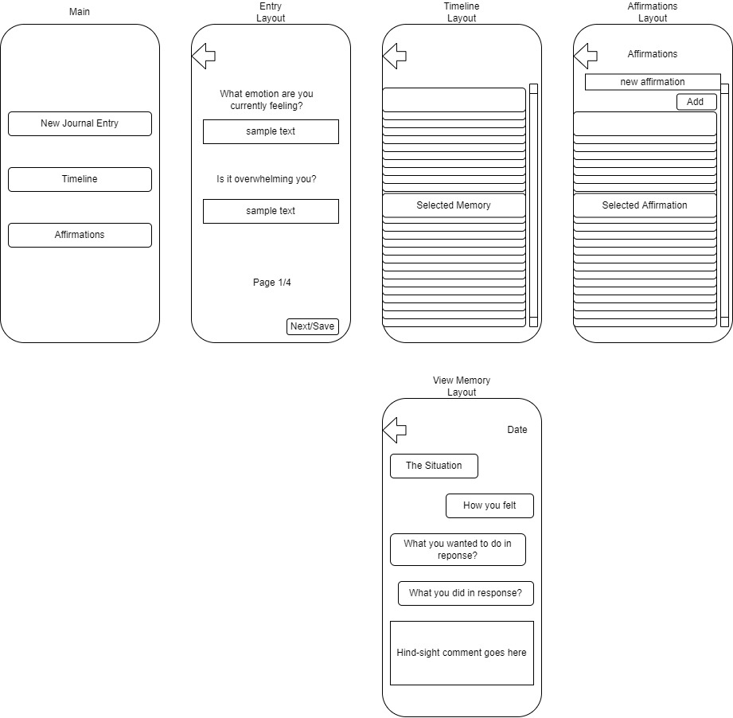

Here is a flowchart of the application usage:

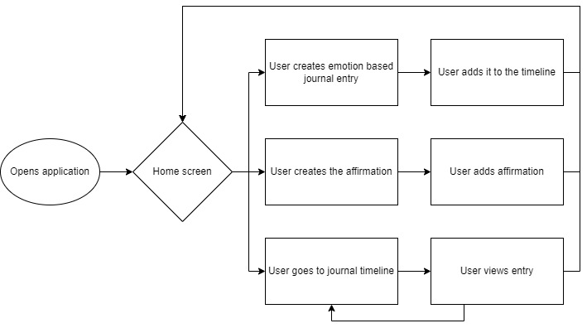

|  |  |  |  |  |  |
| --- | --- | --- | --- | --- | --- |
| Deliverable Acceptance Log | | | | | |
| ID | Deliverable Description | Comments | Evaluator (internal or external as applicable) | Status | Date of Decision |
| 1 | Lighthouse Application | Application still in development, and will be tested by those close to me struggle with the aforementioned problems. | Professor Amr Elchouemi, An Le, Lovelylea Fernandez, Kate Newcomb |  |  |
| 2 |  |  |  |  |  |
| 3 |  |  |  |  |  |
| 4 |  |  |  |  |  |
| 5 |  |  |  |  |  |

|  |
| --- |
| Detailed Solution Architecture |

Here are some class diagrams, unfortunately due to the fact that development hasn’t yet been completed these are likely to be somewhat incomplete:

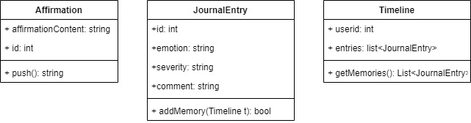

After some thought, I think the analytical process should be relegated to a single scrolling page, because nobody likes clicking through page after page. Once it’s done, it should deposit the user on the timeline page. The timeline page should have a new entry button as well as a return to home button. The home screen should allow you to go to the affirmations page, the timeline page, add a new entry page, and if possible if time permits, which it should, a good day checklist.

The application is only located on an individual user’s phone at this juncture, which is presumably password protected, therefore in an attempt to keep the application as simple as possible, making the user login again, would just add frustration, and that’s antithetical to the point of the application, therefore, it is unnecessary and won’t be added. There is also not going to be any sort of network connectivity within the application so it won’t create any vulnerabilities for the user’s phone that way either, thus eliminating the need for security because of that as well.

|  |
| --- |
| Hardware and Software Technologies |
| 1 – Android 12+ phone |
| 2 – Android Studio |
| 3 - |
| 4 - |
| 5 - |

|  |
| --- |
| Revision and Signoff Sheet |

**Change Record**

|  |  |  |
| --- | --- | --- |
| **Date** | **Editor** | **Revision Notes** |
| 9/4/2022 | Kurt Newcomb | Initial draft for review/discussion |
|  |  |  |
|  |  |  |

|  |
| --- |
| **Overall Instructor Feedback/Comments** |